Patient Instructions to Obtain Copies of Medical Records
Thank you for allowing Gracelight Community Health the opportunity to be your health care provider. Please review the following guidelines and instructions to expedite receipt of your medical records.
Disclosure Process and Fee Explanation
As a patient, you have a right to copies of your medical information. In addition, medical records are legal documents that must be maintained by Gracelight Community Health. California law allows a medical group 15 business days to produce copies of your medical records from the date your authorization is received (CA H&S Code 123110(b)).
Under federal and state law, Gracelight Community Health or its medical records Release of Information provider, Sharecare Health Data Services, LLC (Formerly BACTES Imaging Solutions), is allowed to recover certain costs related to making copies of your medical records available to you. The fee we charge is cost-based to include only the labor, materials and postage as allowed by HIPAA and highlighted by the Omnibus Final Rule. The requested output method will impact the cost to you. As an example, if a 40-page record costs you $ 11.84 on paper, a CD will cost you $10.42.
We have provided you a Medical Record Request Packet (attached) with instructions to request copies of your medical records. In order to process your request, please complete and submit the Authorization for Use or Disclosure of Health Information Form to our Release of Information personnel.

Please note the following:
- We do not accept authorizations by fax.
- Incomplete or missing information from your Authorization may impact and delay the turnaround time of your request. A patient service center representative will follow up with you if your request is not
complete; incomplete requests will be voided after 30 days.

You may mail or drop off your packet in person to the Gracelight Community Health Release of Information Department at the address noted below or complete the packet and leave it at one of our convenient Gracelight Community Health locations. The health center will forward your request to our Release of Information Department below:

Gracelight Community Health
Attn: Medical Records Department
4618 Fountain Ave
Los Angeles, CA 90029
Our personnel stand ready to assist you in completing the attached forms and answering any questions that you may have about the required information. After submitting the attached information, if you have questions about the status of your records, please call our patient service center for assistance at 800.560.3800 once assisted, you may be transferred to the Medical Records Department for further assistance. Please allow 5 - 7 business days before calling.

Thank you for allowing us to serve you,
Gracelight Community Health

What to Expect When Requesting Medical Records
U.S. and California legislation has been enacted to protect you, the consumer, against those who would fraudulently use your personal information including personal health information contained in your medical records.
Every medical provider has unique processes and procedures in handling the release of information. At Gracelight Community Health, we provide a standard set of records and medical information when responding to requests for information which adhere to the strict guidelines mandated by your Federal and State government.
The medical information provided to you documents the care given to you during your treatment at Gracelight Community Health. What follows is a summary of the information categories with a brief explanation of what Gracelight Community Health provides when fulfilling medical record requests.
→ IMPORTANT NOTE:
Please be aware Gracelight Community Health, by law, must provide the minimum required information and can only release information you have specifically requested and authorized in the Gracelight Community Health authorization form, nothing more. If no specific direction is given, Gracelight Community Health will provide one (1) year of pertinent information as defined below.

WHAT IS PROVIDED
- Health center Notes: A method of documentation employed by health care providers to write out notes in a
patient’s chart.
- History & Physical (H&P): A report which documents relevant information regarding the patient’s current
health condition. Information includes responses to personal and family medical histories and organ system
examinations in sufficient detail to manage the patient’s present condition.
- Consultation: A report documenting the diagnosis, prognosis and treatment of the patient’s case.
- Lab: The most recent laboratory reports performed for the patient.
- Radiology: All radiology reports (CT Scans, MRIs, Ultrasounds, X-rays, and Nuclear Medicine Studies.).
- Diagnostic Studies: Most recent EKG’s, Echocardiograms & reports dealing with the heart.
- Surgery / Pathology: Operative reports which document all aspects of surgery and the findings of any
specimens removed and sent for diagnosis.

WHAT IS NOT PROVIDED
Billing, Films, Pathology Slides or Outside Records.
The above information may be obtained by contacting these departments directly.

Patient Record: _______________________

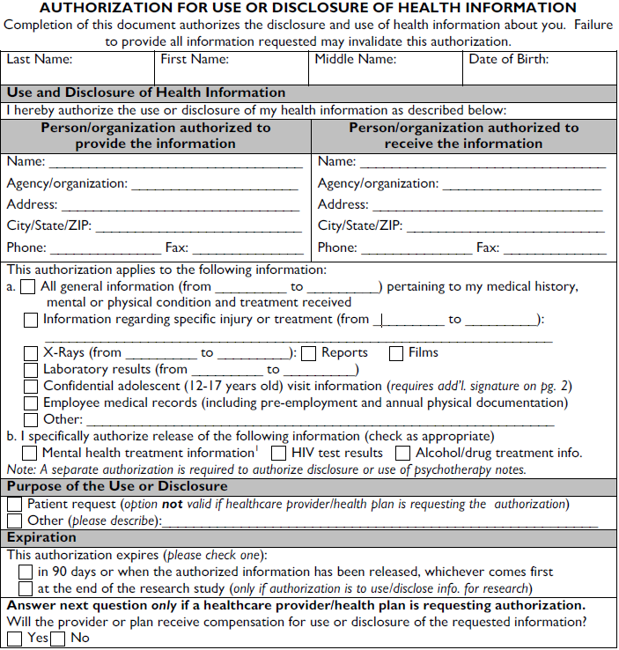

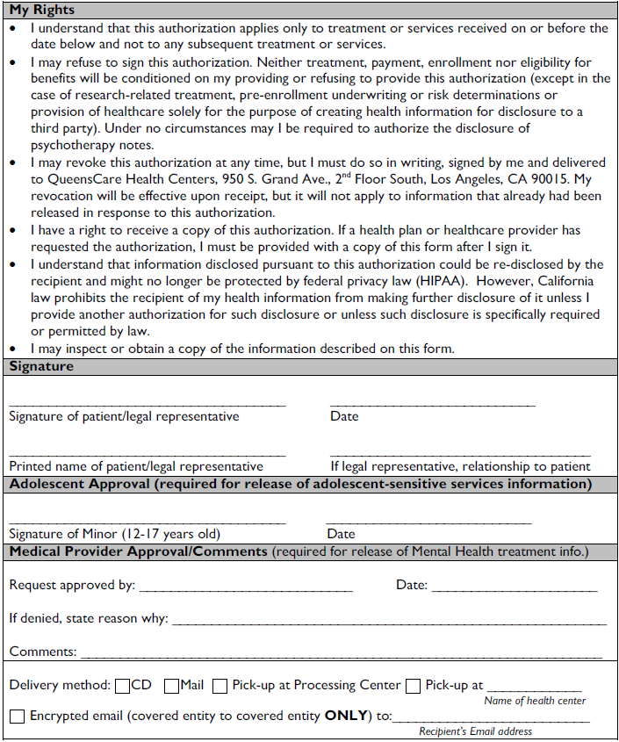
Authorization received by: ________________________________ on: __________________________

Medical Record Payment Form

CA CIVIL CODE 123110: California Patient Access to Health Records. Inspection and copying; Paragraph
(b) Additionally any patient or patient’s representative shall be entitled to copies of all or any portion of the patients records that he or she has a right to inspect, upon presenting a written request to the health care provider specifying the records to be copied, together with a fee to defray the costs of producing the requested records.

*** Important ***
Please note payment will not be collected by Gracelight Community Health. Sharecare Health Data Services will provide an invoice and collect the payment.

Date: _____________________ Patient Record #: __________________________

Patient Name: ________________________________ Daytime contact #: ________________________

